- Over view of Department

Since its inception the Department of Electrical Engineering has registered remarkable growth in teaching & research. It has well established laboratories & scopes for research work. It offers regular 4 year B.Tech program in Electrical Engineering. Through its renowned faculty members, Laboratories with sate of the equipment and infrastructures, the department is actively engaged with various research and development activities besides imparting regular teaching. Most of the faculty members of the department published papers in referred international/ National conference. Several leading originations are regularly visiting the department for campus placements. The department hosts a center of excellence in industrial electronics & robotics, sports and cultural activities with participants to boost interdisciplinary research and relationship among various departments.
In addition to B.Tech in Electrical Engineering the new branch electrical and computer engineering has been introduced in the year 2020, which includes program educational objectives for both the Electrical Engineering and Computer Engineering program of study. These branches are forefront of practical technology.
These branches make us fit to keep our world running from the microchips inside our cell phone to large aircraft electrical system. Now a day we can’t imagine life without electricity and IT.

Subjects to Study

“Electrical / Electrical and Computer engineering is the field where we deal with the energy that runs our world. It can be exists in various forms like gas, fuel cell, turbine, hydro, solar, wind or geothermal energy.

The field deals with the study, design and application of equipments, device and systems which use electricity. These are the versatile core branches where electrical engineers create, design and manage electricity to help power the world. They are the problem solvers who study and apply the physics and mathematics of electricity, magnetism and electronics to both large and small scale systems to process information and transmit energy to the entire world.
Today, electrical engineering not only involves in electrical appliances, but also involves in computer, electronics, communication and mechanical fields. It is divided into many subfields that include electronics, digital computers, power engineering, telecommunications, control systems, radio-frequency engineering, signal processing, instrumentation and microelectronics.

Specific tasks vary according to the role, specialism and employer but typically they could include:

- Involve in job safety training and comply with all established rules and methods to ensure safe and healthy work atmosphere.
- Comply and enforce all safety plus GMP policies.
- Supervise automation system upgrades implementation having conveyors robotic systems, product handling and palletizing systems.
- Assist Maintenance Department for equipment repair.
- Record in documents all electrical design changes.
- Train technical staff in PLC troubleshooting and Electrical Systems.
- Design new electrical engineering and control systems.
- Perform with site staff and external experts to supervise and enhance site electrical systems utilization.
- Head investigations along with site staff to identify and resolve plant electrical system issues.
- Head and direct efforts to enhance electrical plant efficiency.
- Assist construction projects as needed with on-location technical support.
- Support plants start-ups along with commissioning activities.
- Develop standard technical specifications and basic engineering drawings.
- Review every electrical drawings prepared by Owner’s Engineer having single line diagrams.
- Develop 3-line diagrams, wiring and connection diagrams controlling schematics, lighting, grounding and raceway layouts.

Future of students
Electrical Energy being the prime energy sources for every sector, after completing B.Tech in Electrical Engineering there are a number of job opportunities for candidates in Power Generation, Power Transmission, and Power Distribution sectors. Almost all the government sectors, manufacturing units in public and private sectors also need Electrical Engineers. Students can opt higher studies (M.Tech/ PhD) in Electrical Power system, Power Electronics & Drives and Computer Science after completing their B.Tech course. Some of the companies who regularly recruit electrical engineers are listed below.
- Power Grid Corporation of India Limited (PGCIL)
- Power Transmission Corporations of India
- Power Distribution Corporations of India
- Bharat Electronics Limited (BEL)
- Hindustan Aeronautics Limited (HAL)
- National Aluminum Company Limited (NALCO)
- Bharat Aluminum Company Limited (BALCO)
- National Thermal Power Corporation (NTPC)
- Bharat Heavy Electricals Limited (BHEL)
- Steel Authority of India Limited (SAIL)
- Oil and Natural Gas Corporation (ONGC)
- Coal India Limited (CIL)
- Indian Railways
- Air port Authority of India
- IPCL, MCL, etc
Besides that students are also eligible to appear Exam various Administrative jobs like IAS, IES, IPS etc., along with jobs in banking sectors.

- Vision and Mission
The Mission:
- To impart quality education in the fields of Electrical Engineering Science and Technology at Undergraduate as well as Postgraduate levels with special attention to encourage innovation and creativity in these fields in a clean and healthy environment.
- To impart high quality education to the students and carry out fundamental and industry-oriented research work.
- To engage in creation of knowledge and development of technologies through effective research programs.
The Vision:
A Centre of Excellence vibrant with academic activities and bubbling with youthful creative energy, making significant contribution to the World of Knowledge and Technology and to the development of the State and the Nation.
Programs Offered
Program | No of Seats
B.Tech – Electrical Engineering  B.Tech – Electrical and Computer Engineering  Diploma – Electrical Engineering | 30  30  30

- Faculty
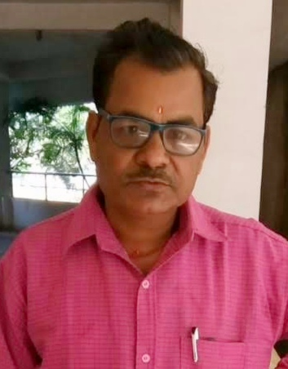
Name: Pabitra Mohan Dash (HOD)
Educational qualification: PhD* (BPUT, Odisha)
Total years of experience: 19+
Specialization: Power System Engineering
Publication of paper: 17

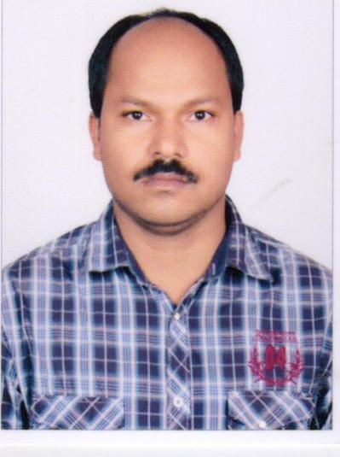
Name: Gouri Sankar Behera
Educational qualification: M. Tech, SOA University, BBSR
Total years of experience: 16+
Specialization: Power Electronics and drives
Publication of paper: 02

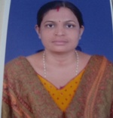
Name: Dr. Swarnaprava Sahoo
Educational qualification: PhD, SOA University, BBSR
Total years of experience: 08+
Specialization: Power Antenna and Microwave
Publication of paper: 13


Name: Jyoti Ranjan Swain
Educational qualification: M. Tech, BPUT Odisha
Total years of experience: 4+
Specialization: Power System Engineering
Publication of paper: 02

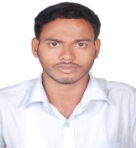
Name: Bijay Kumar Sahu
Educational qualification: M. Tech, BPUT, Odisha
Total years of experience: 7+
Specialization: Power System Engineering
Publication of paper: 02

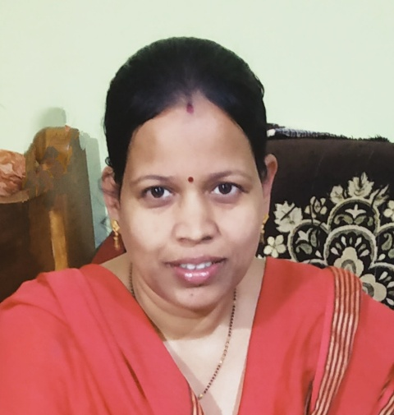
Name: Rasmita Behera
Educational qualification: M. Tech, BPUT, Odisha
Total years of experience: 8+
Specialization: Power System Engineering
Publication of paper: 02

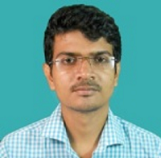
Name: Abhisek Manna
Educational qualification: M. Tech, WBUT, West Bengal
Total years of experience: 3+
Specialization: Control System & Drives
Publication of paper: 04
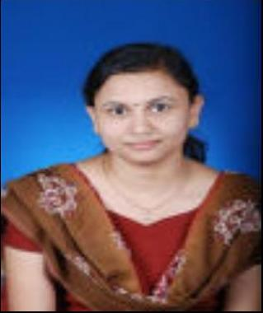
Name: Nalini Sahoo
Educational qualification: M. Tech, BPUT Odisha
Total years of experience: 8+
Specialization: Power System Engineering
Publication of paper: 01

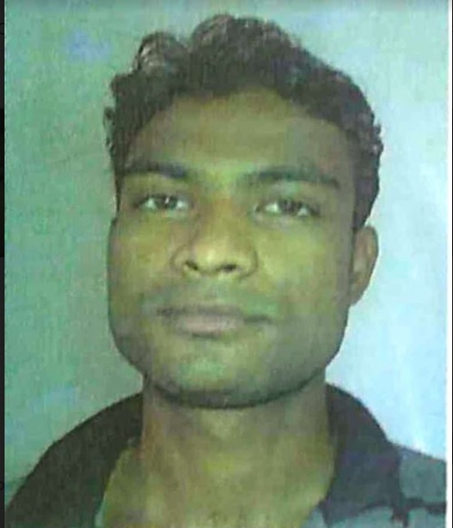
Name: Jyoti Ranjan Swain
Educational qualification: M. Tech, BPUT Odisha
Total years of experience: 10+
Specialization: Electronics & Communication Engineering
Publication of paper: 04

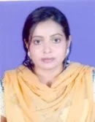
Name: Smita Rani Patra
Educational qualification: M. Tech, KIIT University
Total years of experience: 4+
Specialization: Power System Engineering
Publication of paper: 03

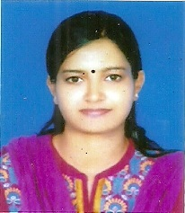
Name: Sushree Silpika Pattanayak
Educational qualification: M. Tech, BPUT Odisha
Total years of experience: 6+
Specialization: Communication System Engineering
Publication of paper: 02

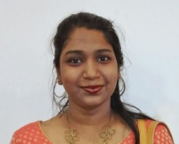
Name: JagyanseniSahoo
Educational qualification: M. Tech, SOA University, BBSR
Total years of experience: 4+
Specialization: Communication System Engineering
Publication of paper: 01
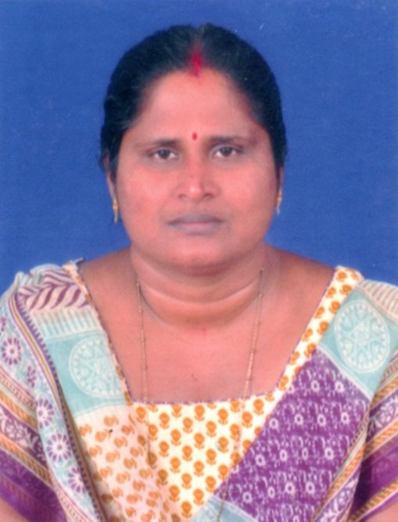
Name: Swapnarani senapati
Educational qualification: B. Tech, JRN UNIVERSITY
Total years of experience: 6+

- Facilities

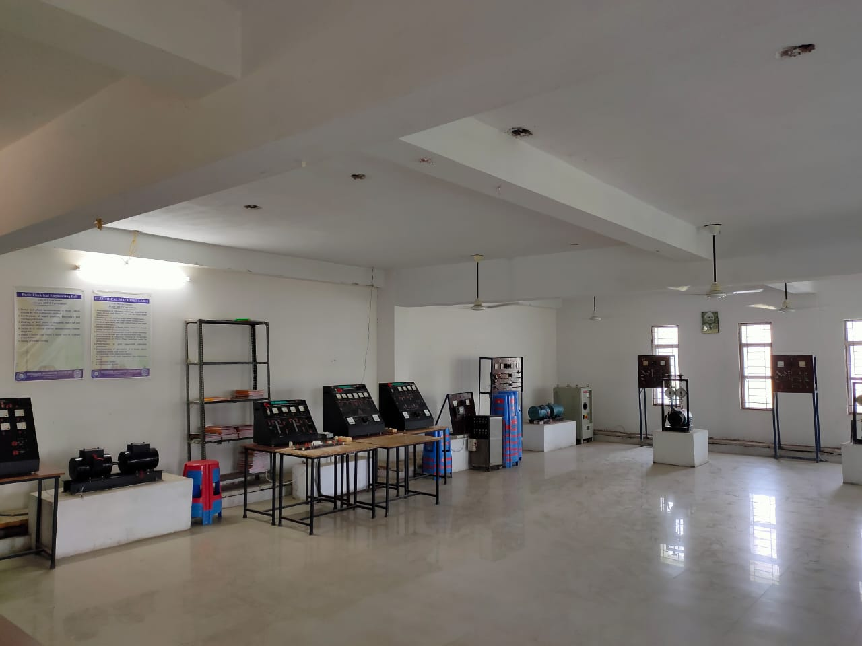
With lab photo

Basic Electrical Engineering Lab
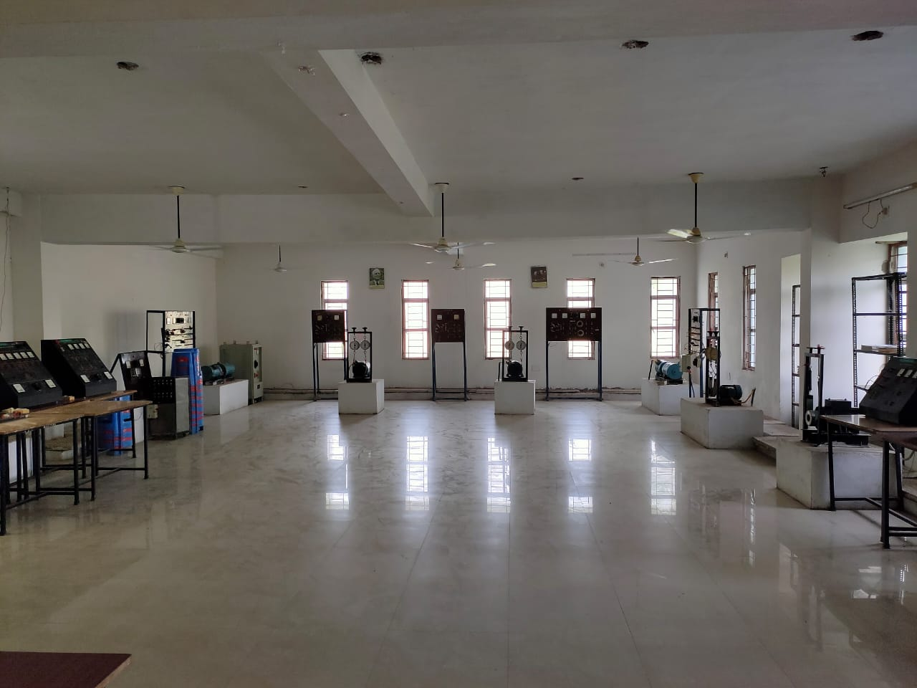
Objective of this laboratory is to improve the technical expertise of all students undergoing 1st year B Tech courses through laboratory practice and experimental studies on topics mainly covered in Basic Electrical Engineering so as to make them aware of electric energy which is being the index of development in determining the economy of the whole nation. It provides grass-root information on basic electrical and electronic circuits along with various components, principle and operation of DC and AC machines etc(mainly on topics covered in RBE1B201……) so that students can realize and strengthen their research potential with the basic knowledge and fundamental aspects of electrical power and engineering.

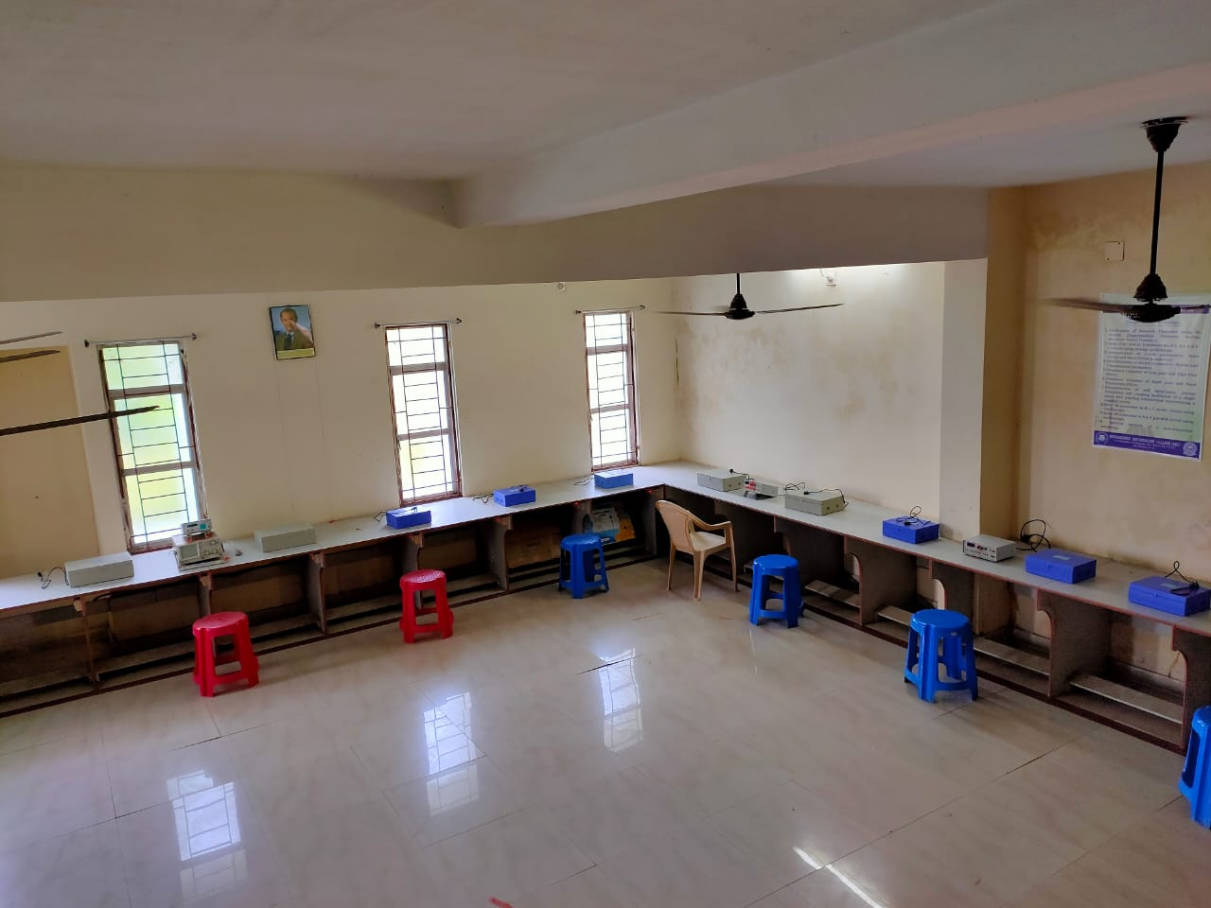
Network Device & Electrical Measurement Lab
Objective of the Measurement Laboratory (REE4D003) is to provide the basic ideas about study and Measurement of various electrical/ Electronic quantities/ parameter using basic electrical instruments. It trains the students how to measure AC and DC voltage, current, power & power factors, resistance, inductance, capacitance, calibration of voltmeters and Ammeters along with study of instruments like Galvanometer and Spectrum Analyzers etc.

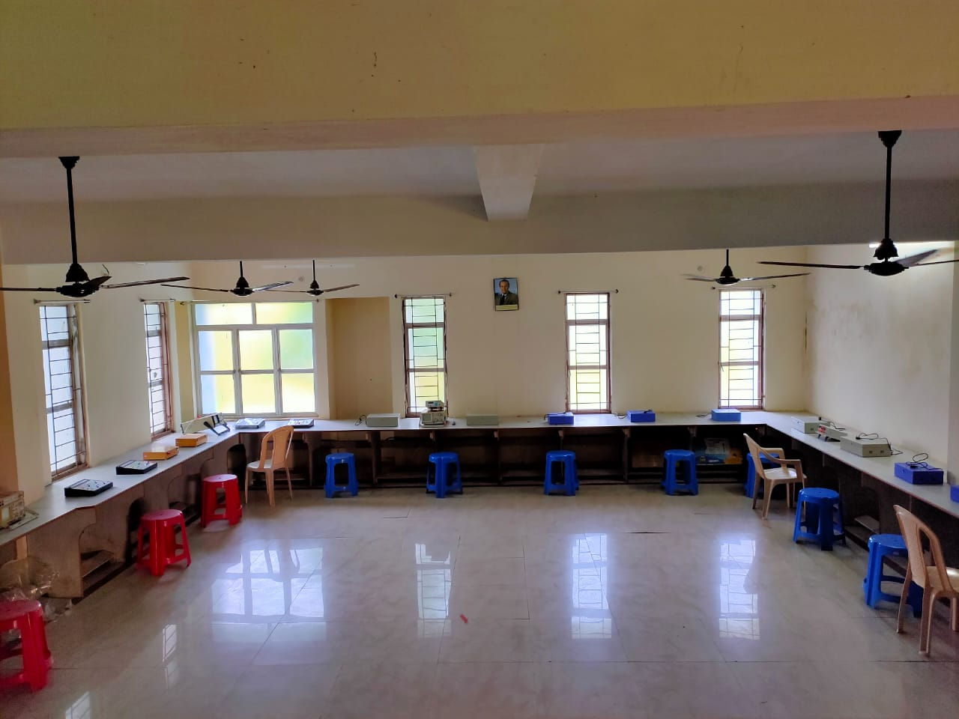
The Electrical Network Device Lab (REE3C202) is a cluster of multiple networking devices, including Oscilloscope, Spectrum Analyzers, Transformer using coupled circuit, filters, and various kits to study network theorems circuit parameters, DC and AC transients etc.

Material covered in both cases includes exercises in graphical circuit solutions, charging and discharging characteristics of capacitors, reactance and impedance measurements in AC circuits, and circuit resonance. In these labs students get significant exposure to the oscilloscope, function generator, and other more sophisticated laboratory equipments.

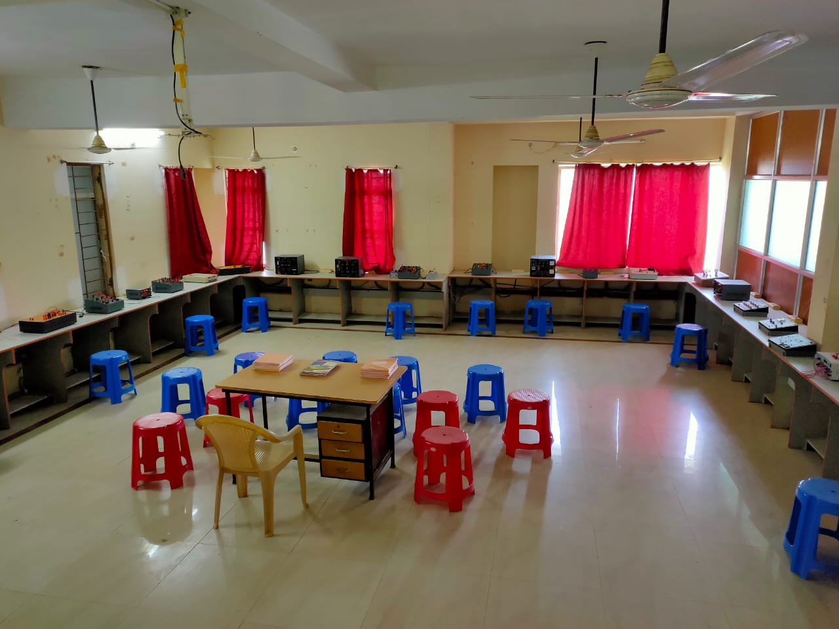
Power Electronics & Control and Instrument Lab
The PE Laboratory (REC4C203) is a unique opportunity for students to design and build power electronic circuits which are the backbone of almost every modern convenience such as Automobiles, cell-phones, laptop and desktop computers, television sets, kitchen appliances and among many other systems along with almost all industries to convert electrical energy to a useful form.
Material covered in this lab makes a student capable enough to construct electronic circuits using solder, printed circuit boards, and breadboards and to use converters, inverters, thyristers, MOSFET etc.
The objective of control and Instrumentation Lab aimed at understanding the common control schemes, analyzing the system response and stability in time-domain and frequency domain, learning and designing the features of different types of compensators, controllers. It also make students capable to study various characteristics of devices like servo motor, lag led compensator thermocouple, synchroscope, transfer function analyzer and to measures strain developed in cantilever beam, linear displacement using LVDT, unknown resistance, inductance and capacitance using bridges etc.

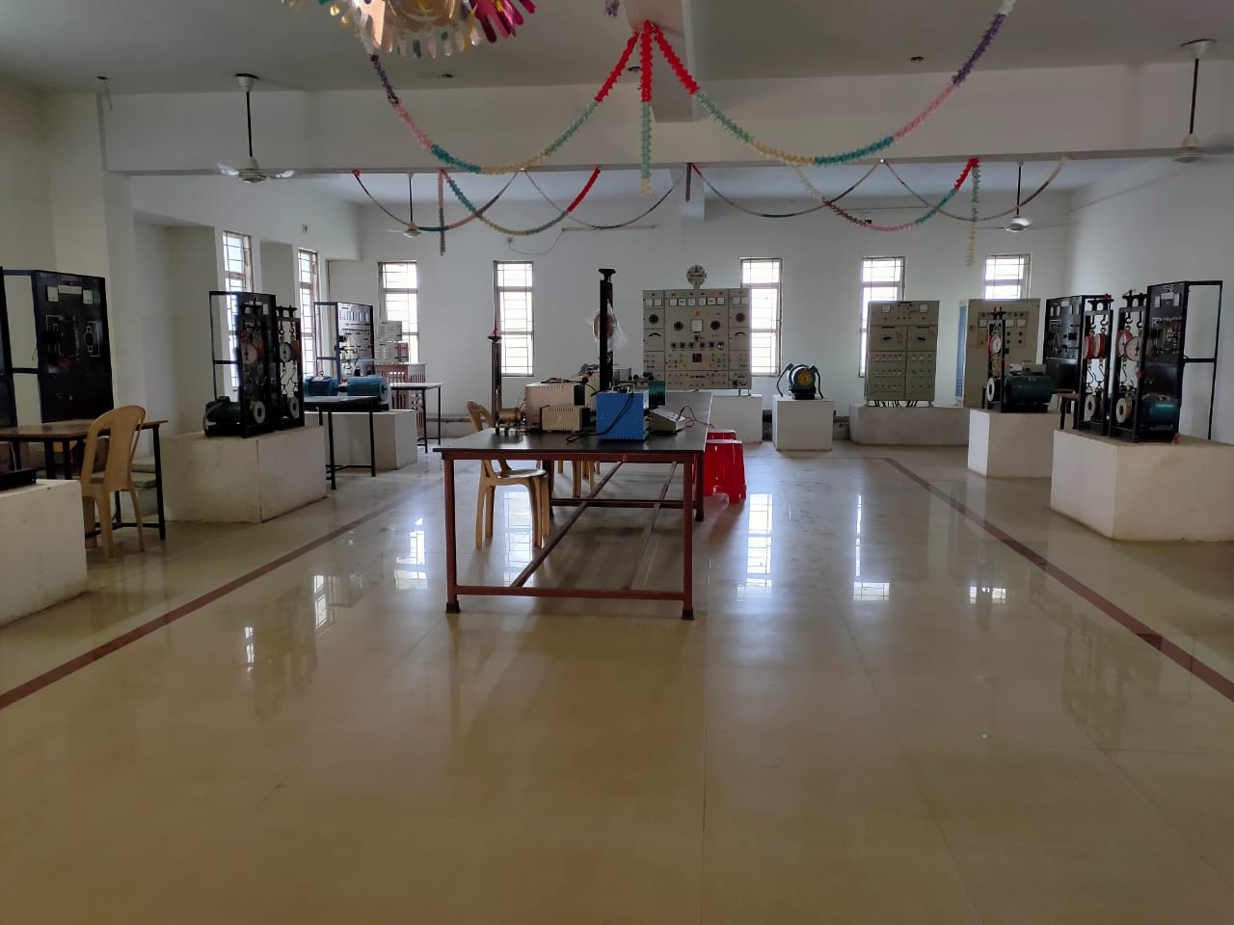

Electrical Machine & Drive Lab
Objective of the Electrical Machine & Drive Lab is to make a student enable to acquire knowledge about the fundamental principles and classification of electromagnetic machines, the constructional details and principle of operation of ac/dc machines, the working of ac/dc machines and transformers with testing and applications etc.
Material covered in this lab makes a student capable
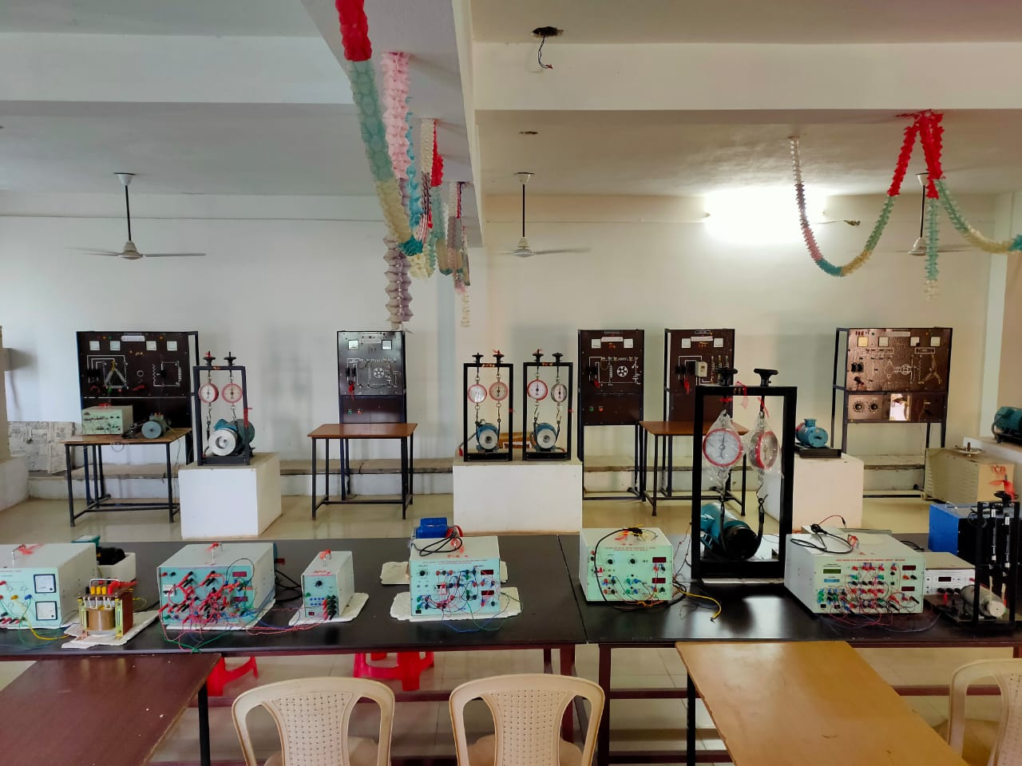
- To understand basic procedures for determining various parameters and characteristics of transformers, ac machines /dc machines.
- To conduct various tests for measuring performances and hence to calculate voltage regulation, efficiency.
- To learn speed control methods of various electrical drives.
- To understand and perform parallel operation of transforms & alternators etc.
.

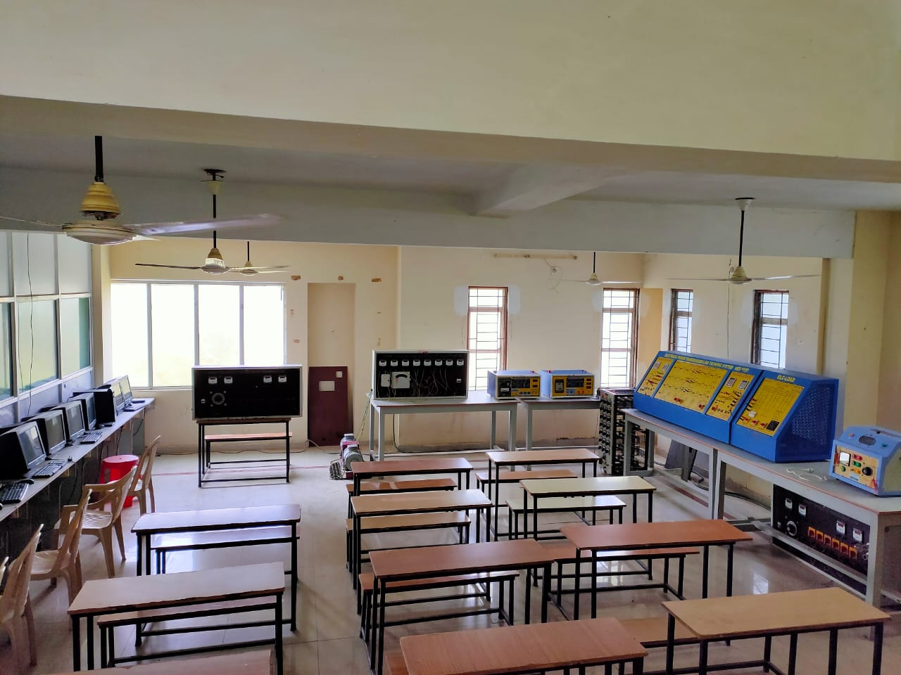
Power System Lab
The objective of this lab is to provide basic knowledge about general structure of power systems, generation of electricity based on conventional and nonconventional energy sources, concept of micro grid and distributed generation.
It makes students capable to analyze mechanical and electrical design aspects of transmission system, protective relays and circuit breakers along with different types of distribution systems and there design.

- Events
- The department of Electrical Engineering (BEC, BHUBANESWAR) conducted a TEQIP-III sponsored National Seminar on “Recent Advanced Technology in Control of Electrical Power & Energy System (RATCEPES)”on 24th – 25th January 2020 inaugurated by Er. Prabhat Ranjan Mallick, Honorable Chairman, KGI for bringing awareness amongst participant about the recent technological advances in Power and Energy Sector. Honorable Director, BEC, Prof. (Dr) B.N Biswal, introduced the guests and briefed about the importance of the Seminar. The program was attended by Honorable Chairman, KGI, Honorable Guests and resource Persons, TEQIP coordinators of BPUT odisha, a number of Delegates and participants. Dr. R.K Jena, Director (CAPGS, BPUT (Rourkela) delivered the keynote address. Finally the vote of thanks was offered by Prof. P.M. Dash, EE, Bhubaneswar.
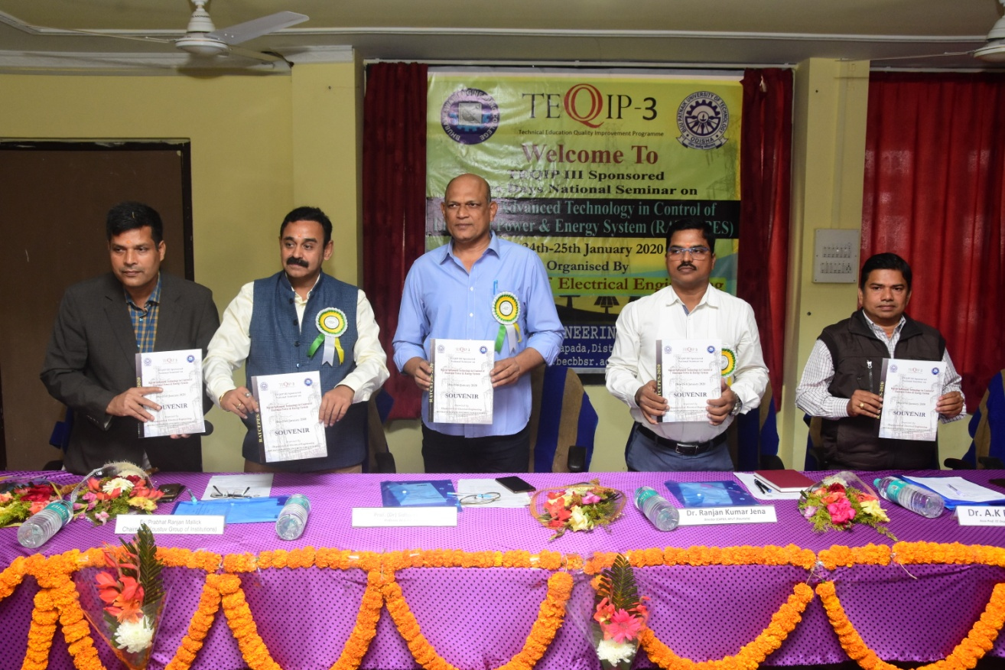

- The department of Electrical Engineering (BEC, BHUBANESWAR) conducted Workshop on “Green Energy Revolution” on 19th November 2019 inaugurated by Prof. (Dr) B.N Biswal, Honorable Director, BEC for bringing awareness amongst students of BEC for rapid growth and implementation of Green Energy as an alternative measure against the conventional sources of energy . Department Head, Prof. Pabitra Mohan Dash introduced the guests and briefed about the importance of the workshop. The meeting was attended by All HODs, faculty members and students. Prof (Dr) M.K Mohanty of OUAT Bhubaneswar and Er. A.K Choudhury, Dy. Director (Tech.) OREDA encouraged the participants through their resource talks. Finally the vote of thanks was offered by Prof. P.M. Dash, EE, Bhubaneswar.
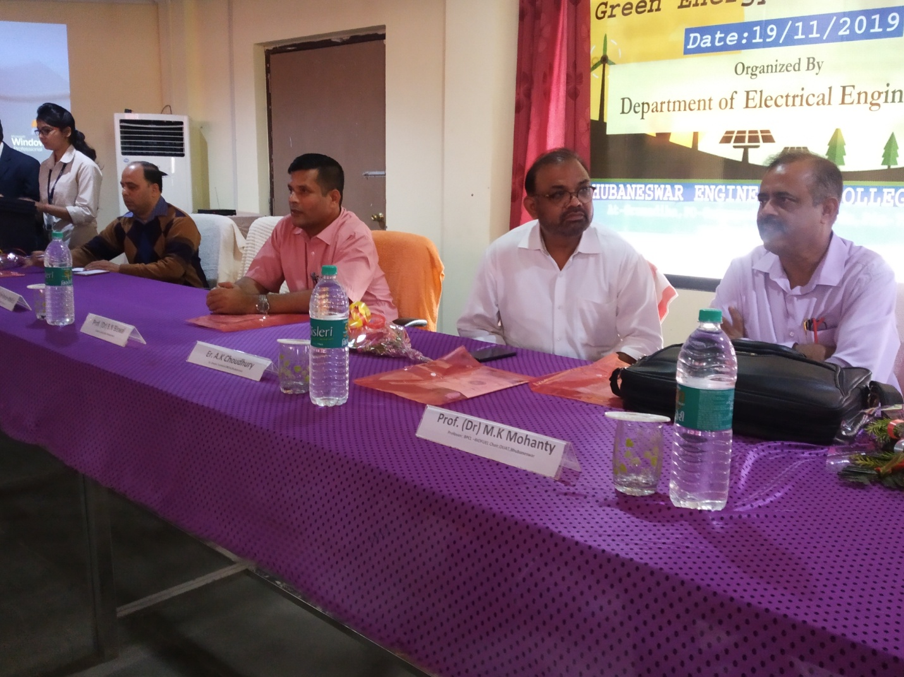

- Syllabus
Syllabus
Lesson Planner Link to PDF and Video

- Student Corner
- Time table

-BPUT previous year Questions
-Question Bank

- Events

Every year the department is organizing Tech-fest, Robotics, annual sports and cultural program (BRITANIKA).

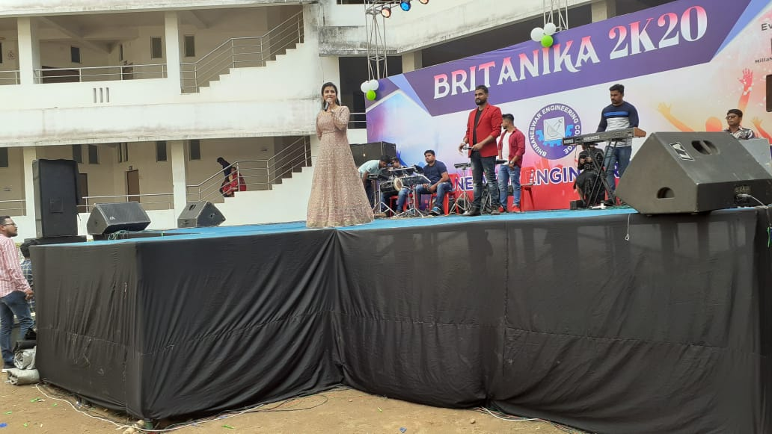
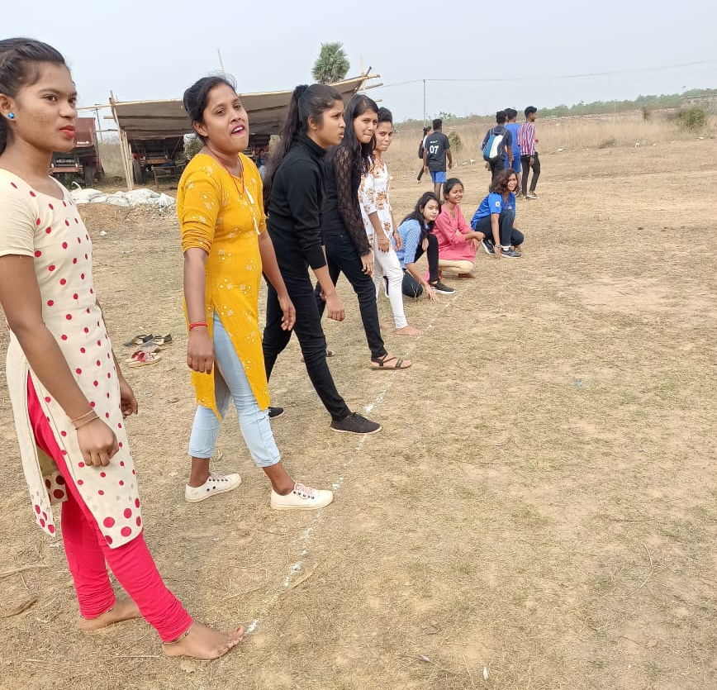
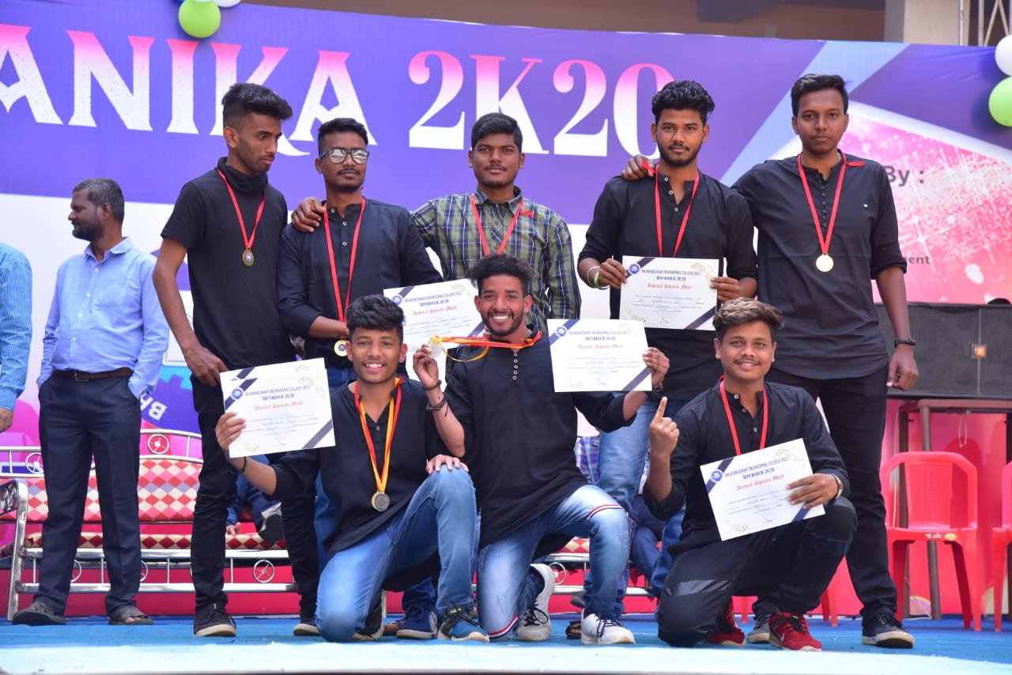
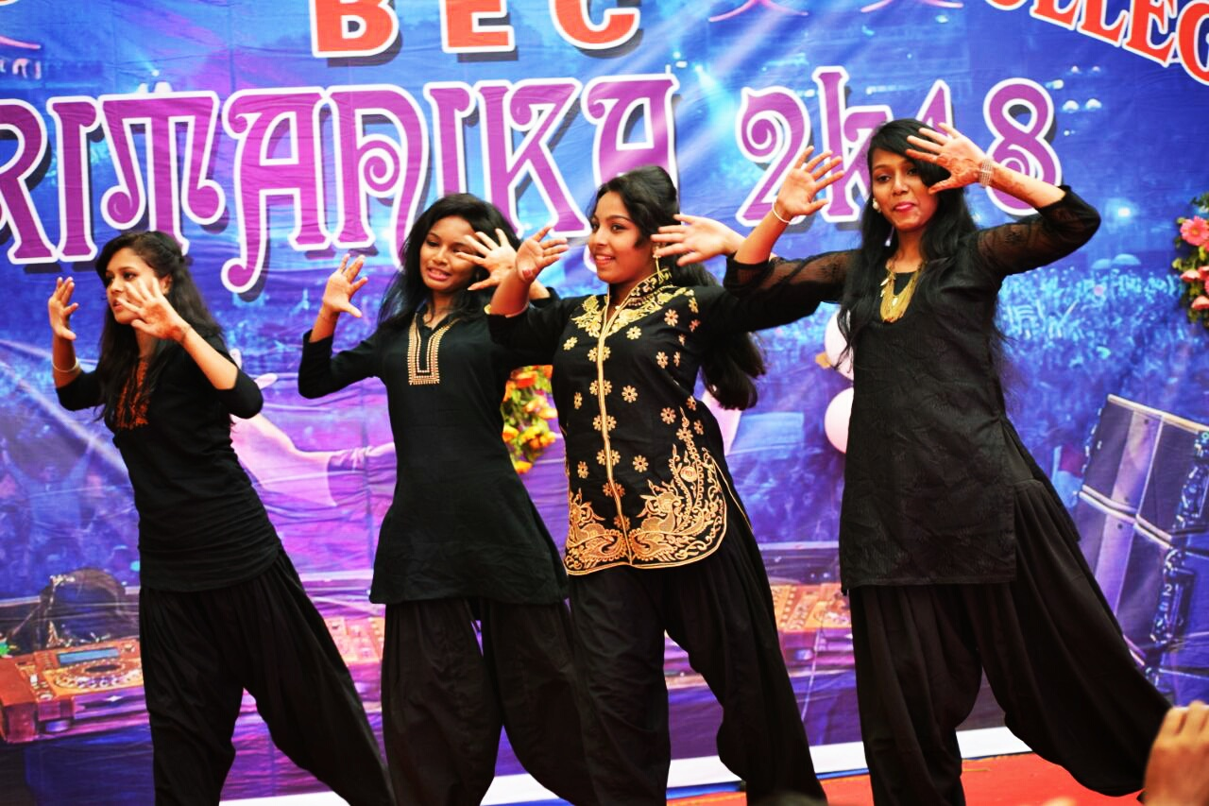

- Photo Gallery

- Student Attendance and Performance (restricted ID)

